SELECT "Imya"

FROM "Sotrudniki"

WHERE "ID_Roli" = 3;

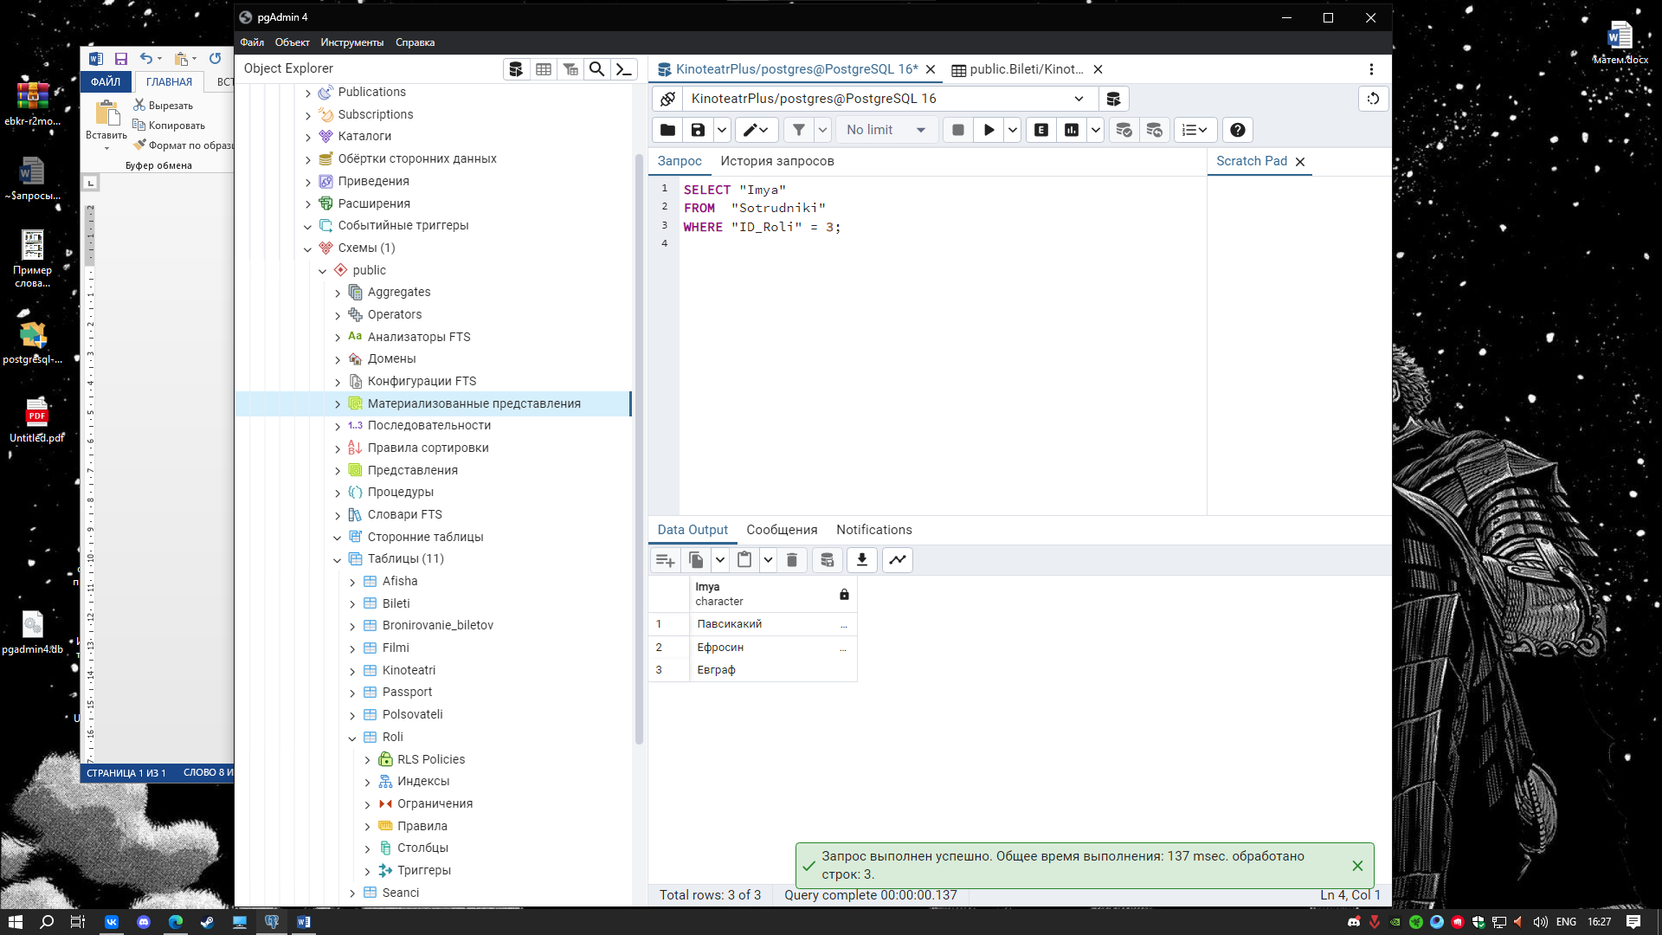

SELECT * FROM "Bileti"

WHERE "Cena" = '550'

GROUP BY "ID_Bileta";

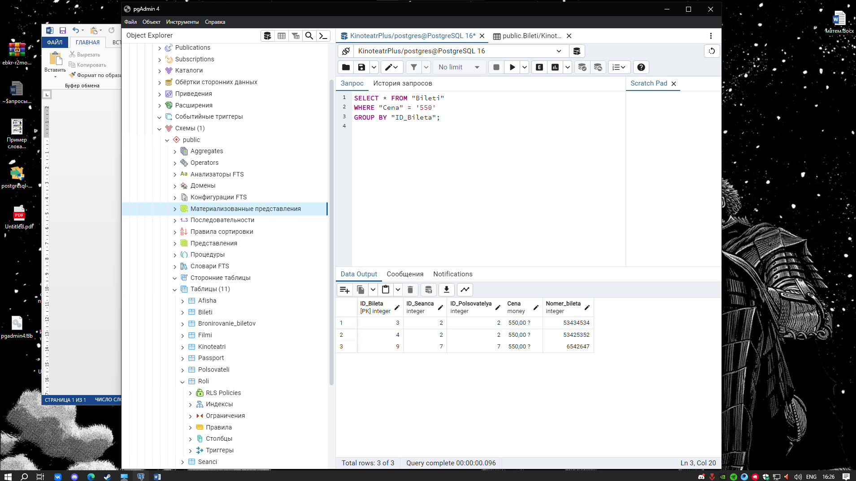

SELECT MIN("Cena"), Max("Cena") FROM "Bileti";



SELECT "Data_vidachi" FROM "Passport"

ORDER BY "Data_vidachi";

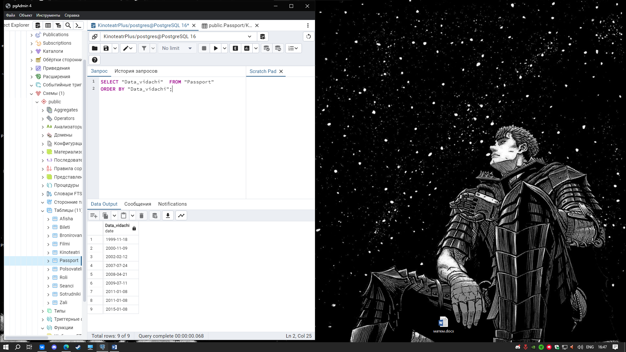

SELECT "Imya", "Data_vidachi" FROM "Passport"

Join "Sotrudniki" on "ID_Sotrudnika" = "ID_Passporta"

ORDER BY "Data_vidachi";

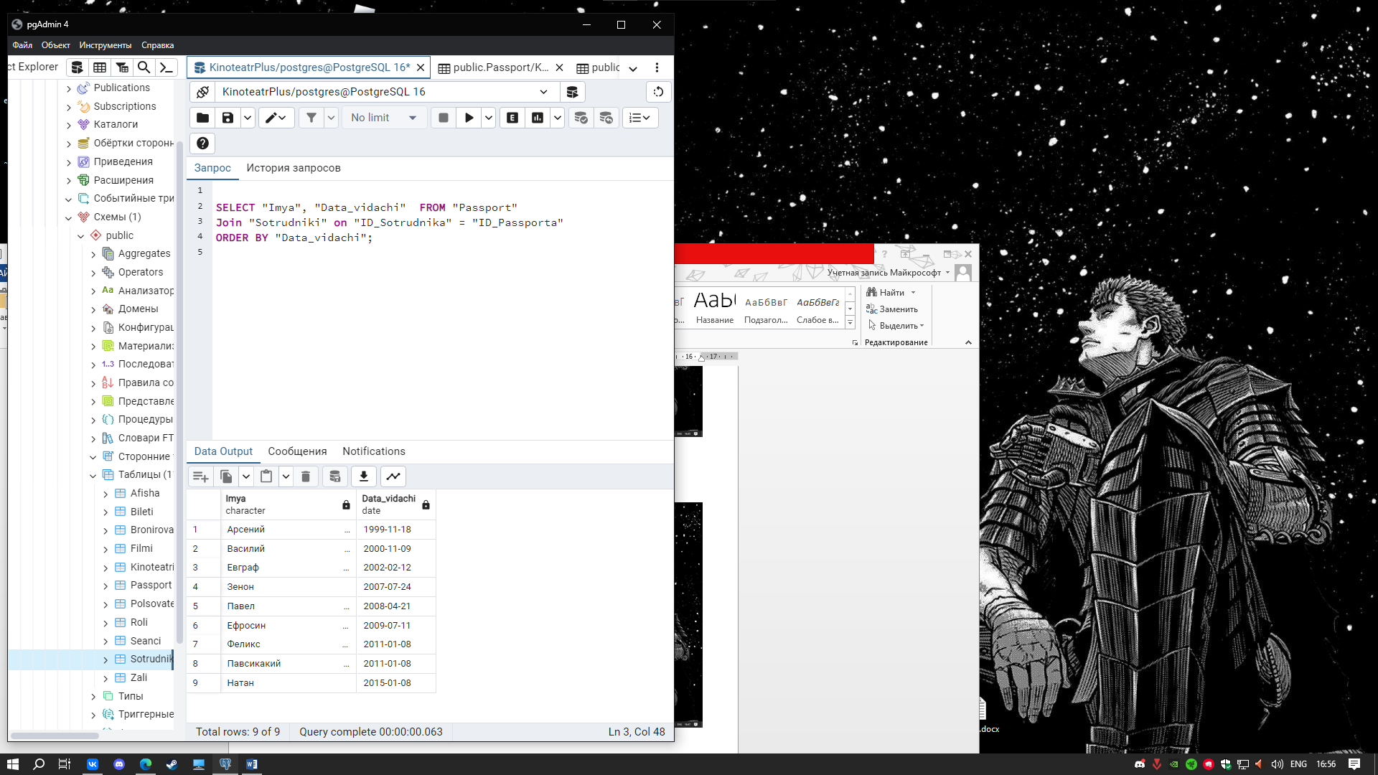

SELECT "Sotrudniki"."Imya", "Sotrudniki"."Familya", "Roli"."Nazvanie"

FROM "Sotrudniki"

JOIN "Roli" ON "Roli"."ID_Roli" = "Sotrudniki"."ID_Roli"

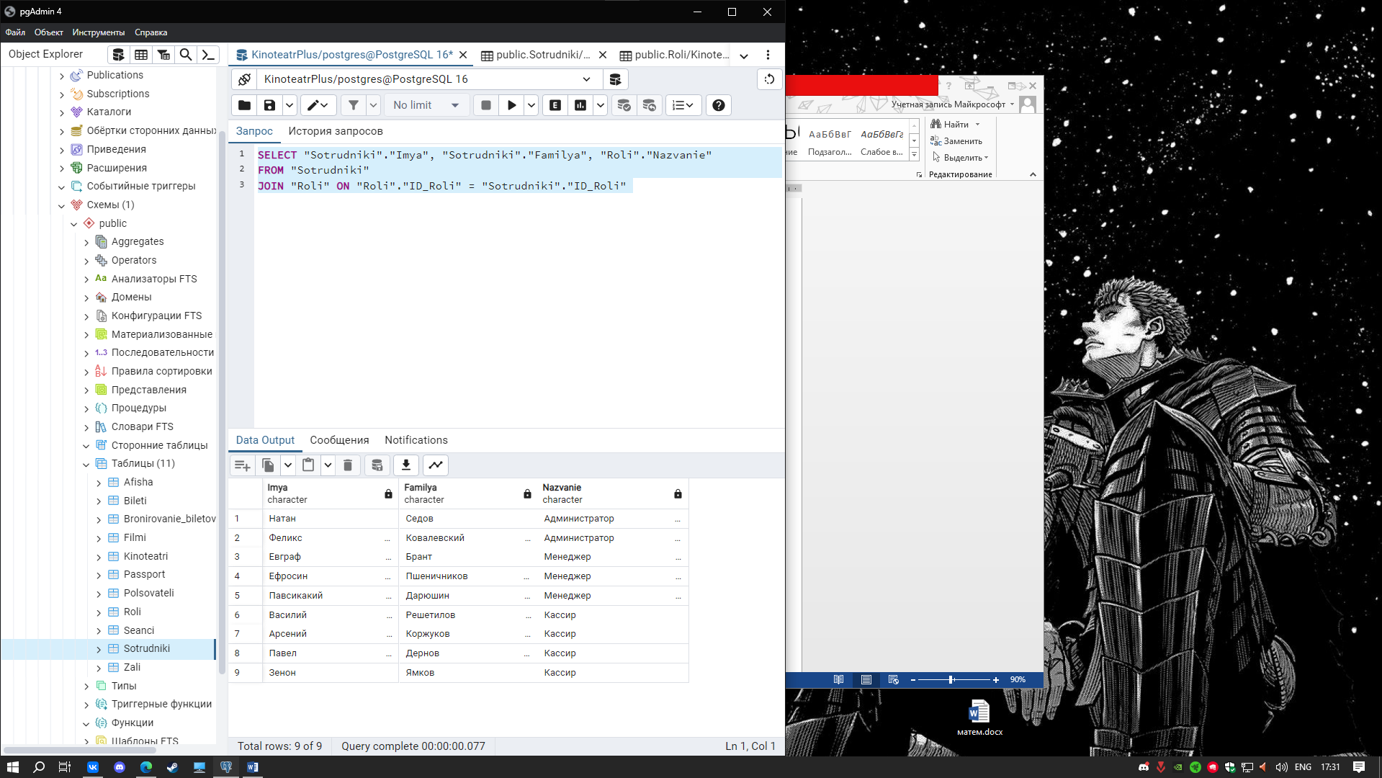

SELECT "Cena" FROM "Bileti" UNION SELECT "Cena" FROM "Bileti";

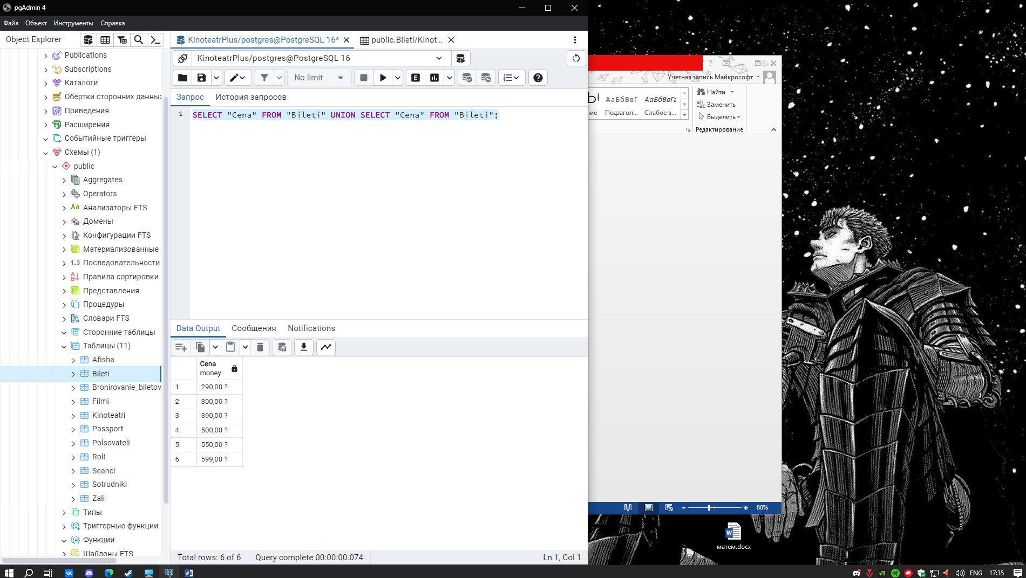

SELECT "Cena", "Filmi"."Nazvanie" FROM "Bileti"

Join "Filmi" on "Bileti"."ID_Seanca" = "Filmi"."ID_Filma"

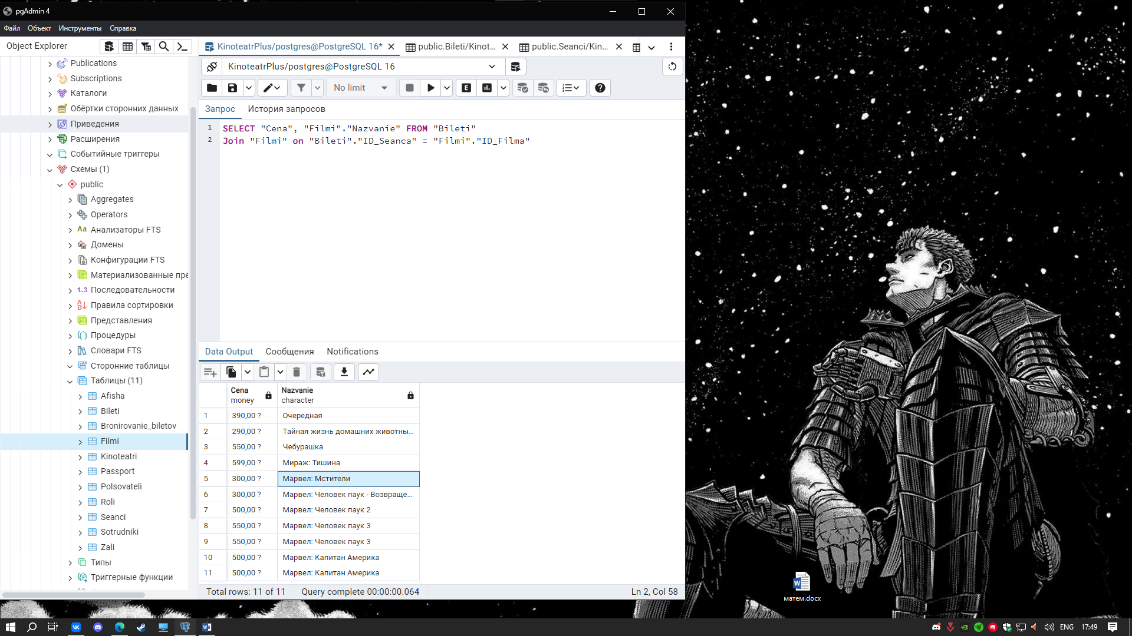

SELECT SUM("Cena") as Prodano_na_Summu FROM "Bileti";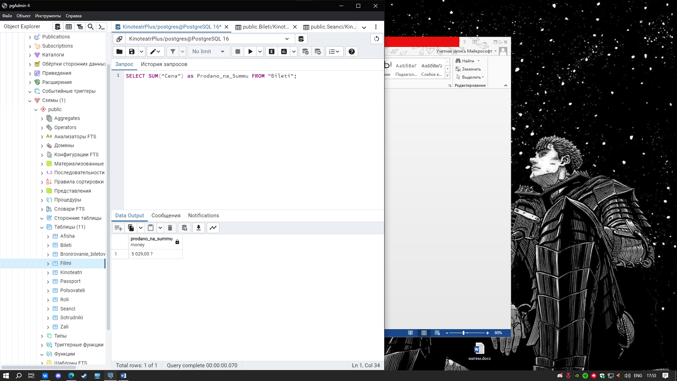

SELECT "Polsovateli"."Imya" as Имя,"Polsovateli"."ID_Polsovatelya" as Уникальный_Код_Пользователя, "Polsovateli"."Familiya" as Фамилия,

"Bileti"."ID_Bileta" as Уникальный_Код_Билета, "Bronirovanie_biletov"."ID_Broni" as Уникальный_Код_Брони, "Bileti"."Cena" as Цена_Билета, "Filmi"."Nazvanie" as Название_Фильма

FROM "Polsovateli"

Join "Bronirovanie_biletov" on "Polsovateli"."ID_Polsovatelya" = "Bronirovanie_biletov"."ID_Broni"

Join "Bileti" on "Bileti"."ID_Bileta" = "Polsovateli"."ID_Polsovatelya"

Join "Filmi" on "Bileti"."ID_Seanca" = "Filmi"."ID_Filma"

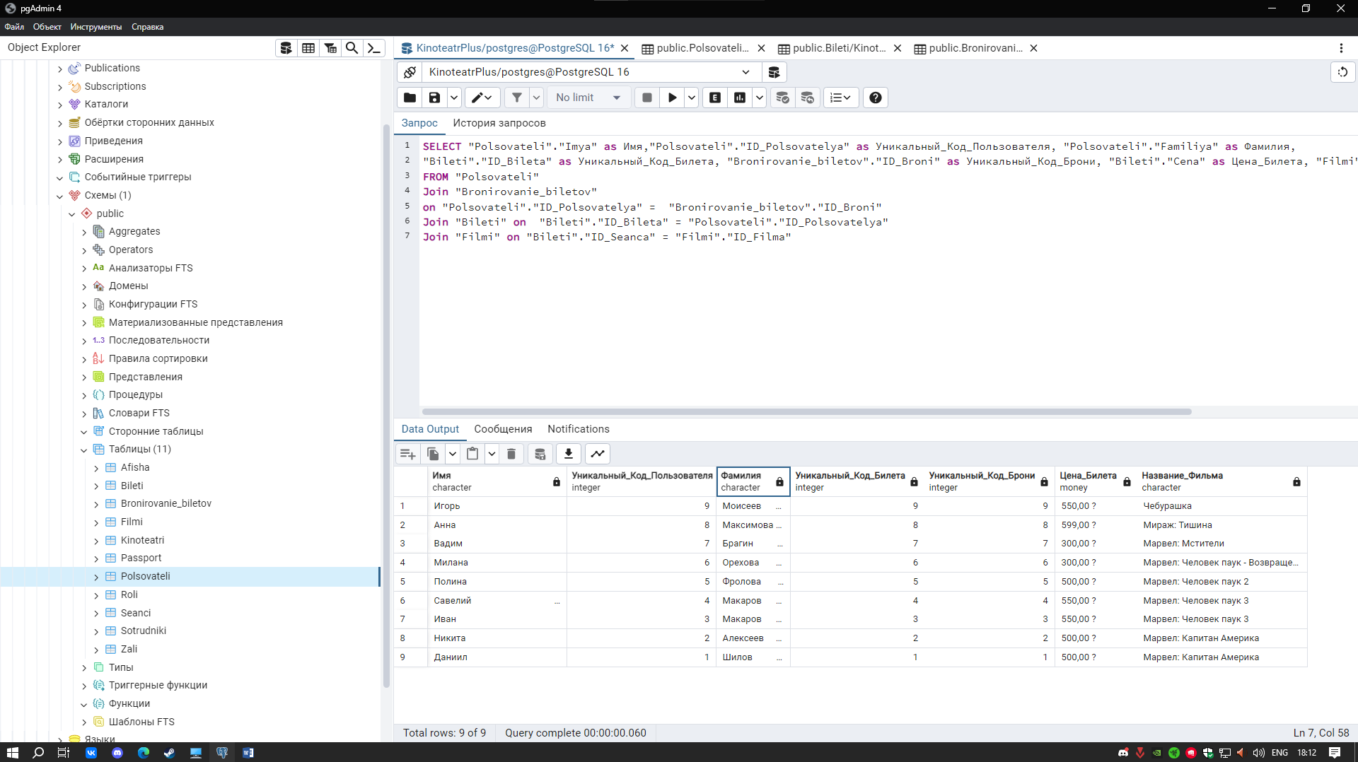

SELECT "Nazvanie", "Adres", "ID_Kinoteatra" FROM "Kinoteatri" WHERE LENGTH("Nazvanie") < 7;

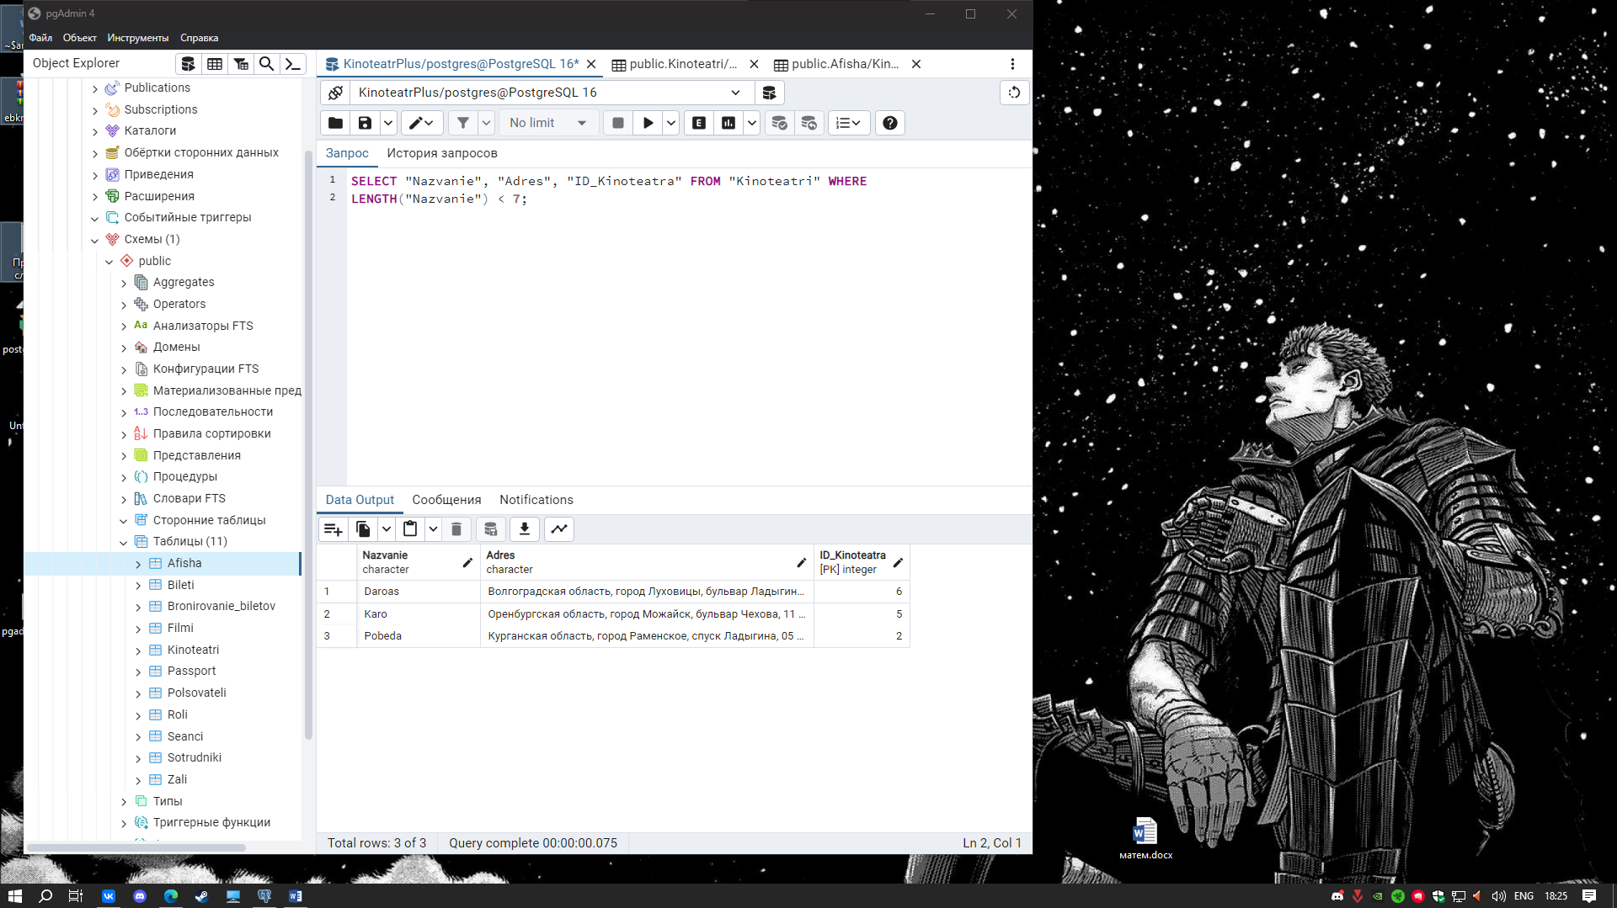

SELECT "Kinoteatri"."Nazvanie", "Filmi"."Nazvanie"

FROM "Kinoteatri"

Join "Seanci" on "Kinoteatri"."ID_Kinoteatra" = "Seanci"."ID_Seanca"

Join "Filmi" on "Kinoteatri"."ID_Seanca" = "Filmi"."ID_Filma"

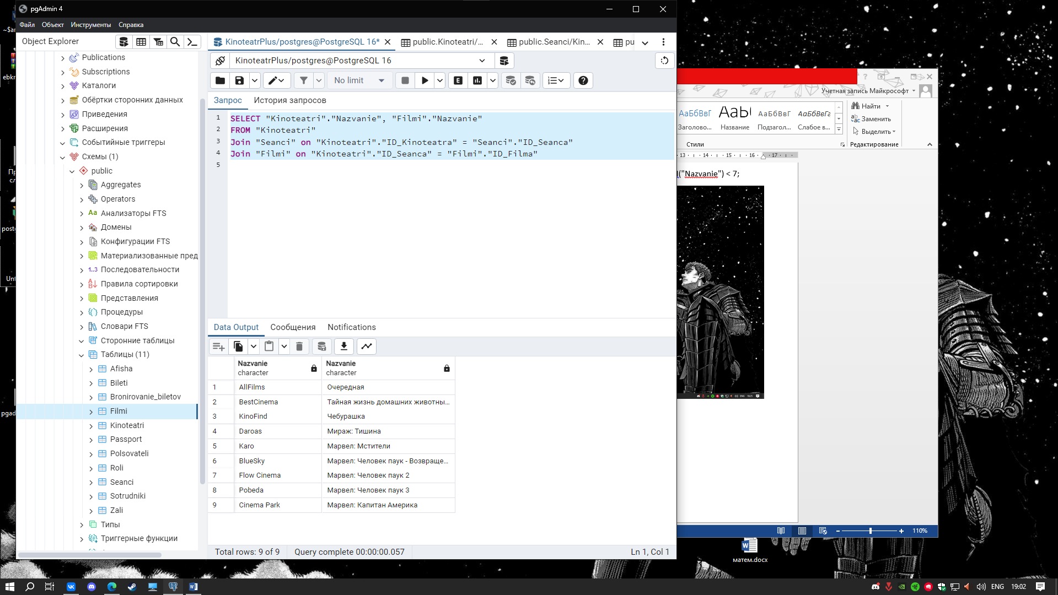

SELECT "Sotrudniki"."Imya", "Roli"."Nazvanie"

FROM "Sotrudniki"

JOIN "Roli" ON "Roli"."ID_Roli" = "Sotrudniki"."ID_Roli" 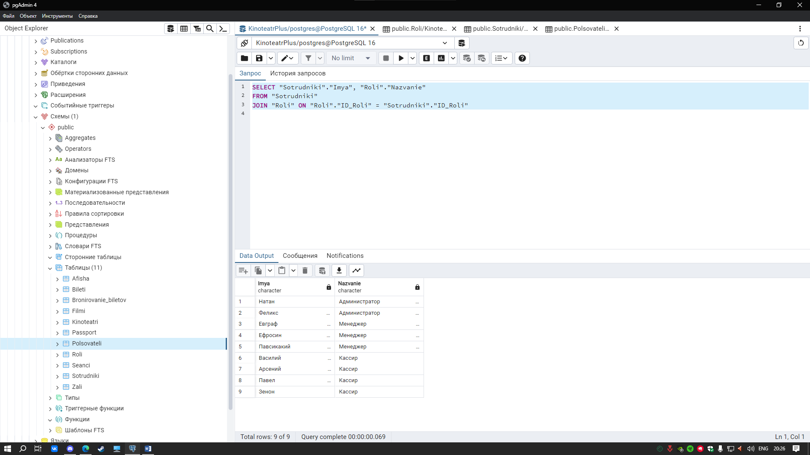

SELECT CONCAT('ID-',"ID_Bileta", ' ' ,"Nomer_bileta",' - Номер' ,' ', "Cena",'.Р') AS Билеты

From "Bileti"

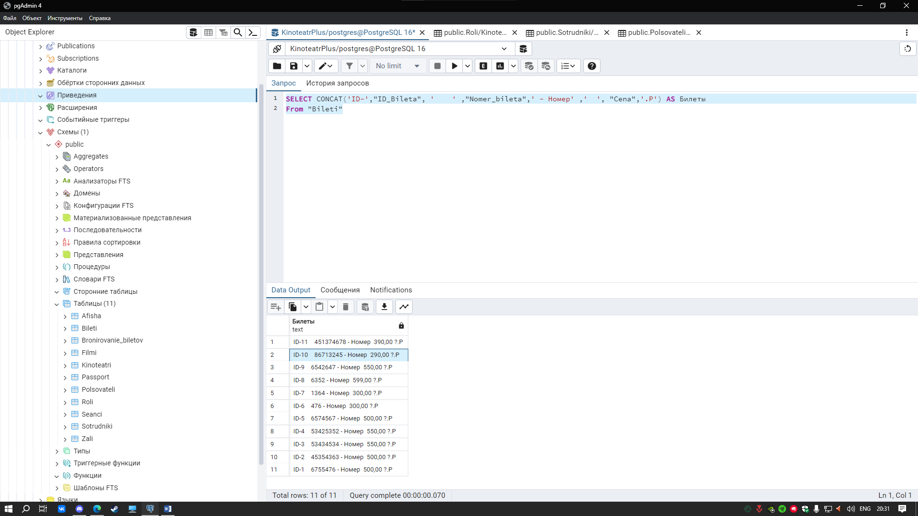

SELECT

SUM("Cena") /

COUNT(*) as Средний_Чек

FROM "Bileti" 